1. I chose first image (as it had best results on layers’ decomposition) for benchmarking.
2. Generated its normalized (divided by number of pixels) cumulative (recursively derived/summed from ordinary histogram) histogram for each channel (R/G/B).
3. Then generated Normalized Cumulative Histograms for the remaining images.
4. Matching was done based on code segment described on the page#73 in textbook.  
   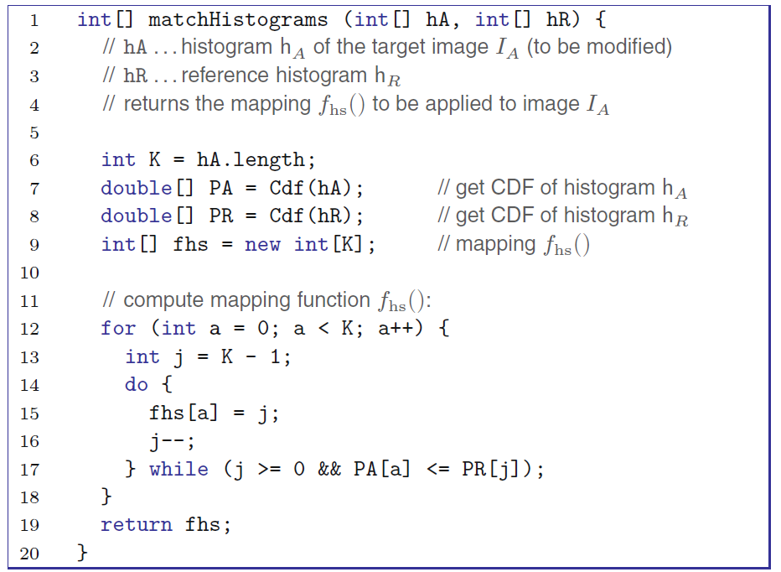

where hA is generated histogram in 3rd step, hR – in 2nd. The output was some mapping function to apply to remaining images to get similar shape in histograms.

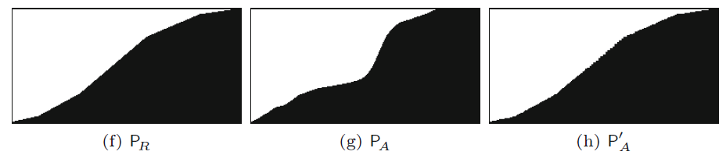

1. So I applied the mapping
2. Then after extraction of Binary Layers the results were significantly improved due to having the images adjusted to Benchmark image.